

**PROTOCOL**to exercise

***Capacitive coupling between two Wires***

|  |  |  |
| --- | --- | --- |
| Class | Secretary | Signature |
| **4BHELS** | **HOFSTÄTTER A.** |  |
| Exercise- / Delivery date | Employee | Signature |
| 4th March 2015 |  |  |
| Teacher | Employee | Signature |
| GRASINGER |  |  |
| Grade | **Employee** | Signature |
|  |  |  |
| ***Capacitive coupling between two Wires*** | | |
| **Used Devices**   |  |  |  |  |  | | --- | --- | --- | --- | --- | | Nr. | Device | Manufacturer | Type |  | | 1. | **Oscilloscope** | **-** |  |  | | 2. | **Function generator** | **-** |  |  | | | |

Inhalt

2 Measurement 1 (Capacitive coupling between the wires) 3

2.1 Measurement Table 3

2.2 Measurement Graph 3

3 Measurements (Signals) 4

3.1 Signal 1: R2=10kOhm 4

3.2 Signal 2: R2=100kOhm 4

3.3 Signal 3: R2=1MOhm 5

3.4 Signal 4: R2=10MOhm 5

# Measurement 1 (Capacitive coupling between the wires)

A 4-pole cable was given and 2 poles were connected to line voltage. On one of the other two poles one side the if resistors with the values 10k, 100k, 1M and 10M were connected with ground. On the last free pin, frequency and amplitude got measured with an oscilloscope and a multimeter.

With the values of the measurements (table) a diagram was drawn.

## Measurement Table

|  |  |
| --- | --- |
| R[Ω] | U2 [V] |
| 10K | 28m |
| 100K | 45m |
| 1M | 80m |
| 10M | 101m |

## Measurement Graph



# Measurements (Signals)

## Signal 1: R2=10kOhm

$$U2=28mV$$

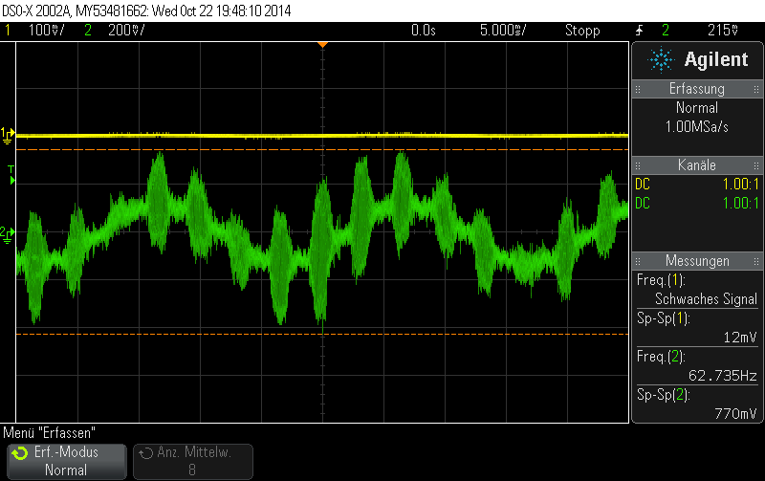

## Signal 2: R2=100kOhm

$$U2=45mV$$

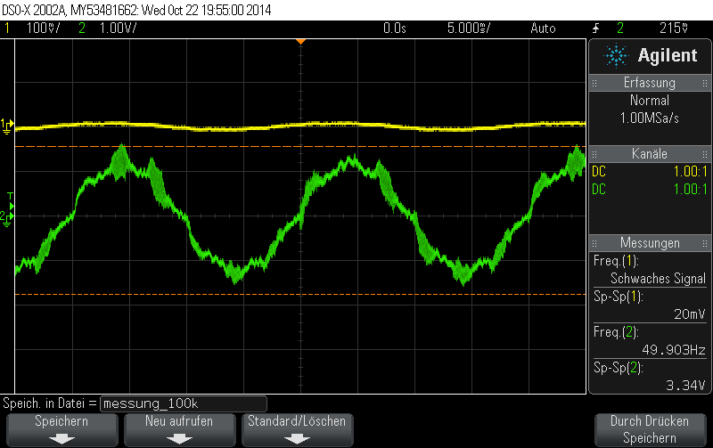

## Signal 3: R2=1MOhm

$$U2=80,7mV$$

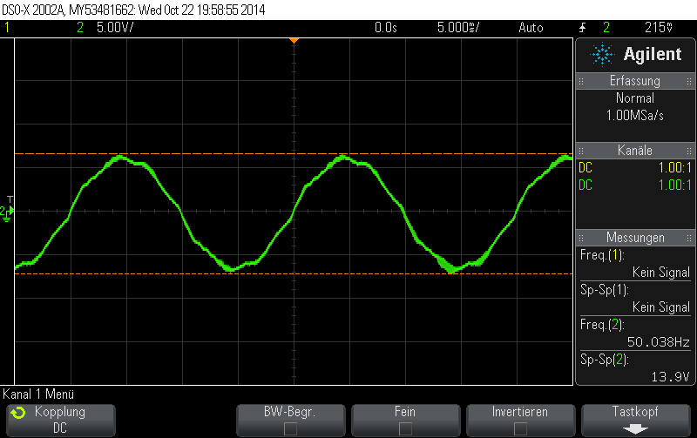

## Signal 4: R2=10MOhm

$$U2=100mV$$

